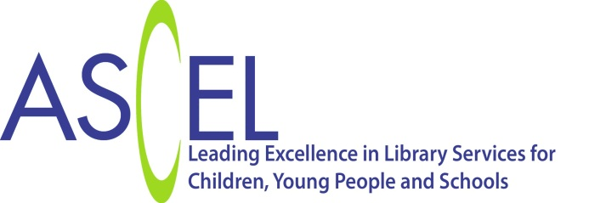

**Press release**

**Children’s Library Journeys**

Libraries have a unique and long term relationship with children and their families. They welcome babies from the very earliest months of life, giving them a love of rhymes and stories and helping them to develop the social and emotional skills they need to be ready for school. Libraries inspire children to read for pleasure throughout their school days, help with study and homework and offer young people opportunities which build employability skills and enable them to make a difference to their communities.

The **Children’s Library Journeys report** published today sets out a national framework for this “Library Journey” highlighting the key interactions public libraries should have with children as they grow. The research behind the report was carried out by Laura Crossley for The Association of Senior Children’s and Education Librarians (ASCEL) on behalf of Arts Council England and The Society of Chief Librarians (SCL). It followed recommendations from the Arts Council England funded Automatic Library Membership Pilot (Siddall, 2014) that there should be a universal offer that “positions the enrolment of each child within a series of staged interactions between an individual and the library service, with regular repetitions of the library message”.

“We are delighted that this work has highlighted so clearly the significance of library services in children’s lives. It has revealed exciting opportunities for new digital engagement and has also emphasized the importance of the library as a rich and welcoming space for children within the local community”. Sarah Mears Chair: The Association of Senior Children’s and Education Librarians.

“We have always known that public libraries play an important role in supporting children's reading and learning through successful programmes like the Summer Reading Challenge and Bookstart. With this research now in place, SCL, through our partnership with ASCEL and other key partners, is committed to supporting the development of a reading journey in all public libraries which builds on these programmes and helps sustain and extend children's use of libraries from birth through to adulthood. We hope that parents, children, teachers along with existing and new partners can help the reading journey have the maximum impact on children's enjoyment of reading and the development of their literacy and other skills”. Ciara Eastell: President of the Society of Chief Librarians.

For more information please contact [sarah.mears@essex.gov.uk](mailto:sarah.mears@essex.gov.uk)

[www.ascel.org.uk](http://www.ascel.org.uk)

@ASCELUK