I’m going to the library

[insert photo of library building]

Before I go to the library

I’m going to [insert name] library | [Insert photo of library building. Change width of all photos to 8cm]
If I am nervous about going I can talk to someone and ask questions first  I can call [insert telephone number] | 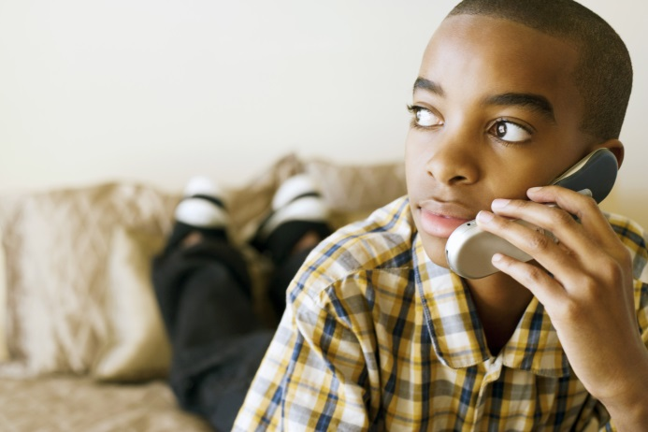
I can ask the person for a tour of the library | [Insert photo of inside of library]

About the library

There are people who work at the library who I can talk to | 
The library is usually a quiet place where people talk quietly, relax and read books | 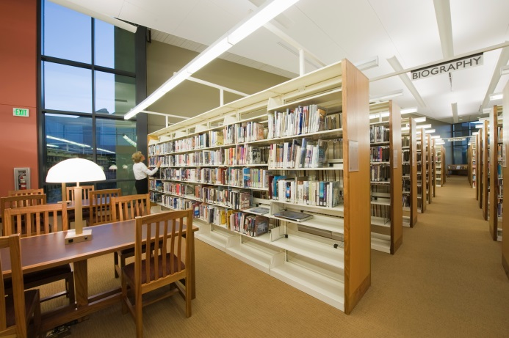
Sometimes it might be noisy. If it is noisy I can talk to a librarian | 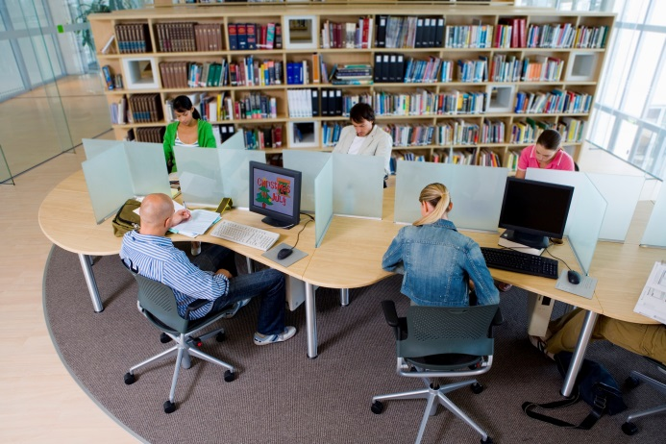

How I become a member of the library

When I get to the library I will see a desk | [insert photo of library front desk]
I will talk to someone who works there to become a member of the library | 
I will tell them my name, address, date of birth, telephone number and email address | 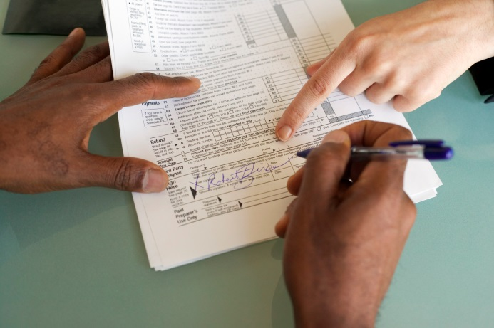
I will show them identification. This can be a driving licence, bank statement or household bill | 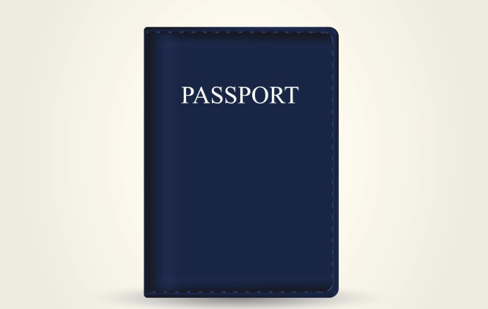
I will sign a form, this makes me a member of the library and I will be given a library card | [insert photo of local library card]

When I visit the library

In the library there will be shelves of books, CDs and DVDs  [delete any if not applicable] | 
I can sit in a chair to read a book | 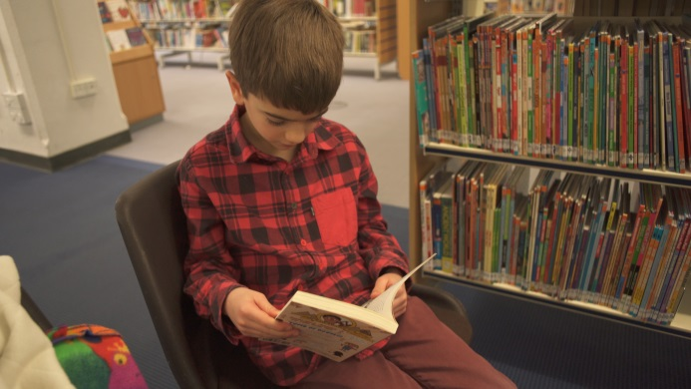
I can borrow a book, CD or DVD and take it home with me  [delete any if not applicable] | 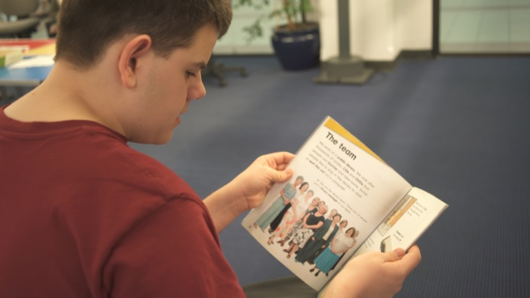
If I want to borrow a book I will talk to a member of the library staff

The staff will show me how to borrow the book, CD or DVD and tell me when I need to bring it back to the library  [delete any if not applicable] | 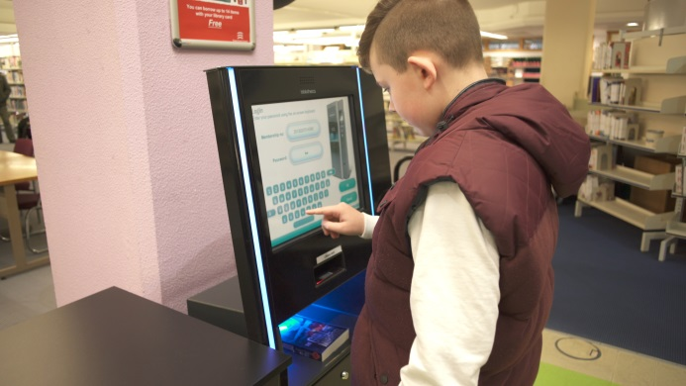
The library will also have some computers | 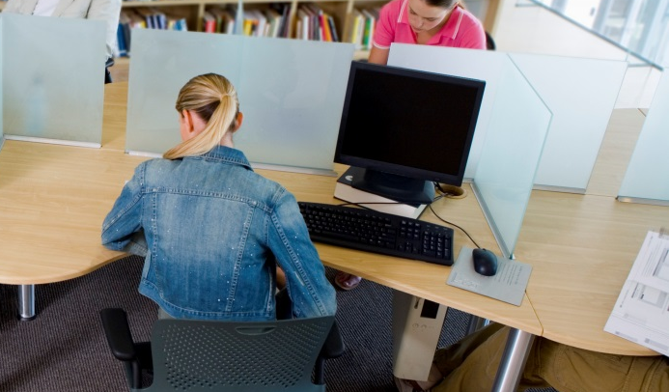
The computers are free to use/I will have to pay to use the computers  [delete as appropriate] | [insert photo of computer section]
To use the computers I will need to reserve a time/wait for one to be available/talk to a member of staff
[delete or add as appropriate]

The library will also have a sensory room I can use  [delete if not applicable] | [Insert photo of sensory room]
When I have finished I will leave the library | [insert photo of library exit]

